Kerri Ellis
Professor Ann Svendsen-Sanchez
NUTR 3334
November 21, 2021
Part 1

Amyotrophic lateral sclerosis, otherwise known as ALS, is a devastating neurodegenerative disease that swiftly attacks the upper and lower motor neurons leading to paralysis and death. There are currently two main types of ALS; the familial and the sporadic form. The familial form is believed to be attributed to a genetic mutation that is passed down from parent to offspring. According to Cozollino (2012), “Familial forms of ALS have autosomal dominant or autosomal recessive inheritance patterns that account for approximately 10% of all ALS cases” (p. 55). The sporadic form accounts for the greater percentage of ALS cases and while a genetic component cannot be ruled out the causative factor can be attributed to any myriad of sources. For example, according to Al-Chalabi (2013), environmental risk factors such as exercise, smoking, heavy metals, pesticides and chemicals, hazardous occupations such as armed services/deployment, electric shock, cyanotoxins and geographical clustering can all potentially contribute to the neurodegeneration known with ALS. The presentation of symptoms are dependent on what region of the body the ALS is affecting. According to Taylor (2016), “Similar to most neurodegenerative diseases, the symptoms starts focally and spreads: symptoms that start as subtle cramping or weakness in the limbs or bulbar muscles progress to the paralysis of almost all skeletal muscles. Some subsets of motor neurons, including those that innervate the extraocular muscles or sphincters, are spared until late in the progression of the disease” (p. 197). The progression of the disease will increase the severity of the symptoms and will eventually lead to paralysis of vital muscles such as the diaphragm, which can lead to suffocation and death. According to Taylor (2016), “ALS is diagnosed in 1-2 individuals per 100,000 each year in most countries”(p. 197). The epidemiology regarding ALS is currently very narrow in its scope due to the usually late onset of the disease and it’s swift progression. However there have been many promising studies hoping to discover some singularities that will help in better understanding how and more importantly who this disease is inclined to target. Currently an ALS diagnostic test does not exist, therefore medical professionals are forced to diagnose and treat patients based on a process of elimination. The ALS Association provides a comprehensive list of some of the most common tests used to establish a positive diagnosis. The following tests are among a few of the common tools used to narrow down an ALS diagnosis: Electromyography (EMG), Nerve conduction velocity (NCV), blood and urine samples (high resolution serum protein electrophoresis, thyroid and parathyroid hormone levels, 24 hour urine collection for heavy metals), spinal tap, x rays (including MRI), myelogram of cervical spine, muscle/nerve biopsy and lastly a thorough neurological examination. Because of the complexity of ALS and the gaps in our understanding of both its pathophysiology and etiology, developing an effective drug treatment has proven to be a difficult undertaking. While pharmaceutical companies all over the world are attempting to develop an effective treatment, the only two that are currently FDA approved and on the market are Riluzole and Edaravone. According to Miller (2017), Riluzole is considered the primary drug treatment for ALS and attempts to modestly slow the progression of the disease as a glutamate antagonist. According to recent studies this drug is only effective in extending a patient’s life by the length of a few months. Edaravone affects the disease as a neuroprotective agent or antioxidant that seeks to prevent or slow down further nerve damage, however its effectiveness is still under much speculation. With the list of medicinal treatments so small and the terminal prognosis of the disease, the prerogative of the medical caregiver is to attempt to slow the disease progression and ensure the patient is comfortable. According to Miller (2017), treatments are provided with the intention of providing comfort to the patient. For example, “Effective treatment for respiratory insufficiency with non-invasive ventilation at night extends life, improves sleep, quality of life and alleviates dyspnea. Dysphagia and weight loss shorten life for these patients, but a percutaneous gastrostomy (PEG) stabilizes weight and improves nutrition”. Novel therapeutic approaches are being developed especially for patients with FALS employing gene silencing with antisense oligonucleotides”(p. 2). According to Al-Chalabi (2013), “Population-based studies repeatedly demonstrate that the median survival of patients with ‘classic ALS’ is 2-3 years from symptom onset”(p. 618). ALS is considered a terminal illness however there are very rare cases where the rate of neurodegeneration will suddenly cease to further decline. This allows the patients to live longer lives yet still be affected by the damage from when the neurological decline was active. One such example is renowned theoretical physicist Steven Hawking who lived with ALS for over fifty years. Currently there are no means of preventing ALS, at this time the best options to a patient are to be diagnosed as early as possible, engage in supporting therapies and to consider one of the many promising ALS clinical trials. Pape (2020) describes the negative impact that ALS has on a patient’s metabolism.
One common factor observed in most ALS patients is altered metabolism. ALS patients struggle to sustain a healthy weight and display altered lipid and/or respiratory metabolism, leading to exacerbated disease symptoms and shorter lifespan. These metabolic symptoms have brought diet to the forefront of treatment. Several researchers have set out to identify diet-based therapies to ameliorate these metabolic alterations and restore healthy metabolism in ALS patients. By implementing specific dietary programs, particularly high-calorie diets, ALS patients have displayed slower disease progression and improved quality of life. (p. 302).
In the same article the authors also demonstrate the significance of a high fat and high caloric diet such as the ketogenic-diet. “The research suggests that a ketogenic diet may be working to protect against ALS by restoring the function of complex I and promoting ATP synthesis” (p. 304). As ALS is a neurodegenerative disease one of the key symptoms is muscle wasting. The primary therapies that are used to combat this condition are physical therapy/occupational therapy and speech therapy. By strengthening and continuing to keep the muscles active, studies have shown these therapies can slow down and/or alleviate discomfort from the progressing nerve damage.

Reference page
Al-Chalabi, & Hardiman, O. (2013). The epidemiology of ALS: a conspiracy of genes, environment and time. Nature Reviews. Neurology, 9(11), 617–628. https://doi.org/10.1038/nrneurol.2013.203
ALS Association. (n.d.). Symptoms and Diagnosis. Retrieved November 21, 2021, from https://www.als.org/understanding-als/symptoms-diagnosis
Cozzolino, & Carrì, M. T. (2012). Mitochondrial dysfunction in ALS. Progress in Neurobiology, 97(2), 54–66. https://doi.org/10.1016/j.pneurobio.2011.06.003
Miller, & Appel, S. H. (2017). Introduction to supplement: the current status of treatment for ALS. Amyotrophic Lateral Sclerosis and Frontotemporal Degeneration, 18(sup1), 1–4. https://doi.org/10.1080/21678421.2017.1361447
Pape, & Grose, J. . (2020). The effects of diet and sex in amyotrophic lateral sclerosis. Revue Neurologique, 176(5), 301–315. https://doi.org/10.1016/j.neurol.2019.09.008
Taylor, Brown, J., & Cleveland, D. W. (2016). Decoding ALS: from genes to mechanism. Nature (London), 539(7628), 197–206. https://doi.org/10.1038/nature20413

Part 2

Amyotrophic lateral sclerosis, also called ALS is a disease that affects your motor nerves. When the disease destroys the nerves, the muscles will no longer be able to receive messages from the brain. This disconnect from the brain will eventually lead the muscles to become weak, then paralyzed and the patient will eventually succumb to death. There are currently two main types of ALS; the familial and the sporadic form. According Cozollino (2012), The familial form is believed to be caused by a mutation that occurs in one or more of our genes, that mutated gene is then passed down from the parent to the child. The familial form is rare and only accounts for approximately 10% of all ALS cases. The sporadic form accounts for the approximately remaining 90% and its definitive cause is currently unknown. According to Al-Chalabi (2013), Genetics along with environmental risk factors such as exercise, smoking, heavy metals, pesticides and chemicals, hazardous occupations such as military deployment, electric shock, exposure to toxins and geography can all play a potential role in developing ALS. How and what type of symptoms you will experience are typically dependent on what region(s) of the body the ALS is affecting. According to Taylor (2016), the symptoms will typically occur at a central point such as the muscles in the hand, foot or the mouth. The patient will begin to experience weakness or cramping In the area, in the tongue for example the patient will begin to have slurred speech. As the nerves are destroyed the disease will spread until almost all skeletal muscle has become paralyzed. According to Taylor (2016), ALS is considered very rare and only “1-2 individuals per 100,000 are diagnosed each year” (p. 197). Because the average age of ALS onset is 55 and the expected length of survival is only 2-3 years, there is a significant lack of available research to determine who ALS is most likely to affect. Currently an ALS diagnostic test does not exist, therefore medical professionals are forced to diagnose and treat patients based on a process of elimination. According to the ALS Association the following tests are among a few of the common tools used to narrow down an ALS diagnosis: Electromyography (EMG), Nerve conduction velocity (NCV), blood and urine samples, spinal tap, x rays (including MRI), myelogram of cervical spine, muscle/nerve biopsy and lastly a thorough neurological examination. Currently there are two FDA approved drug treatments for ALS; Riluzole and Edaravone. According to Miller (2017), Riluzole is considered the primary drug treatment for ALS, the drug works to slow down the progression of the disease by preventing buildup of the neurotransmitter Glutamate in the brain. Edaravone also works to slow the progression of the disease, however this drug works by seeking out and destroying toxic materials that build up due to the progressing ALS. According to recent studies the primary drug Riluzole can be effective at extending life for several months while the drug Edaravone effectiveness is still under much speculation. With the list of medicinal treatments so small and the terminal prognosis of the disease, the primary objective is to attempt to slow the disease progression and ensure the patient is comfortable. One of the key system failures that can occur is respiratory insufficiency due to weakening of the muscles. According to Miller (2017), an effective course of treatment that will not cure but allow the patient to rest more comfortably is known as non-invasive ventilation. “This course of treatment has the potential to extend their life, improve their sleep, improve their overall quality of life and alleviate difficulty breathing” (p. 2). Miller (2017) also speaks of another treatment that has shown to have a positive impact on ALS patients is the (PEG) feeding tube. The tube allows the patients to maintain a healthy weight and has shown to improve the quality of their nutritional intake. Lastly Miller (2017) describes a novel technology that is being developed for patients that are diagnosed with the familial form of ALS. This technique allows for the ALS causing mutated genes to be “silenced” in the patients genetic code. ALS is considered a terminal illness and according to Al-Chalabi (2013), the average survival rate is between 2-3 years. However there are very rare cases where the patient’s life expectancy can extend well beyond that. For example renowned theoretical physicist Steven Hawking who lived with ALS for over fifty years. Currently there are no means of preventing ALS, at this time the best options to a patient are to be diagnosed as early as possible, engage in supporting therapies and to consider one of the many promising ALS clinical trials. A patients metabolism is ravaged by the progressing ALS, and it becomes essential that the patient is able to maintain a healthy BMI. High calorie diets and ketogenic diets are proving to be some of the most beneficial forms of dietary therapy. As ALS is a neurodegenerative disease one of the key symptoms is muscle wasting. The primary therapies that are used to combat this condition are physical therapy/occupational therapy and speech therapy. By strengthening and continuing to keep the muscles active, studies have shown these therapies can alleviate discomfort and/or even slow down the progressing nerve damage.

Reference page
Al-Chalabi, & Hardiman, O. (2013). The epidemiology of ALS: a conspiracy of genes, environment and time. Nature Reviews. Neurology, 9(11), 617–628. https://doi.org/10.1038/nrneurol.2013.203
ALS Association. (n.d.). Symptoms and Diagnosis. Retrieved November 21, 2021, from https://www.als.org/understanding-als/symptoms-diagnosis
Cozzolino, & Carrì, M. T. (2012). Mitochondrial dysfunction in ALS. Progress in Neurobiology, 97(2), 54–66. https://doi.org/10.1016/j.pneurobio.2011.06.003
Miller, & Appel, S. H. (2017). Introduction to supplement: the current status of treatment for ALS. Amyotrophic Lateral Sclerosis and Frontotemporal Degeneration, 18(sup1), 1–4. https://doi.org/10.1080/21678421.2017.1361447
Pape, & Grose, J. . (2020). The effects of diet and sex in amyotrophic lateral sclerosis. Revue Neurologique, 176(5), 301–315. https://doi.org/10.1016/j.neurol.2019.09.008
Taylor, Brown, J., & Cleveland, D. W. (2016). Decoding ALS: from genes to mechanism. Nature (London), 539(7628), 197–206. https://doi.org/10.1038/nature20413

Part 3
Because ALS is such a devastating and swift neurodegenerative disease it is imperative that the selected course of treatment be implemented as soon as possible. Among other vital systems, the disease severely affects a patient’s metabolism. If the patient is unable to maintain a healthy BMI the disease will only progress that much faster. In this example here we are able to see the stages of ALS and the symptoms that will occur at each stage.
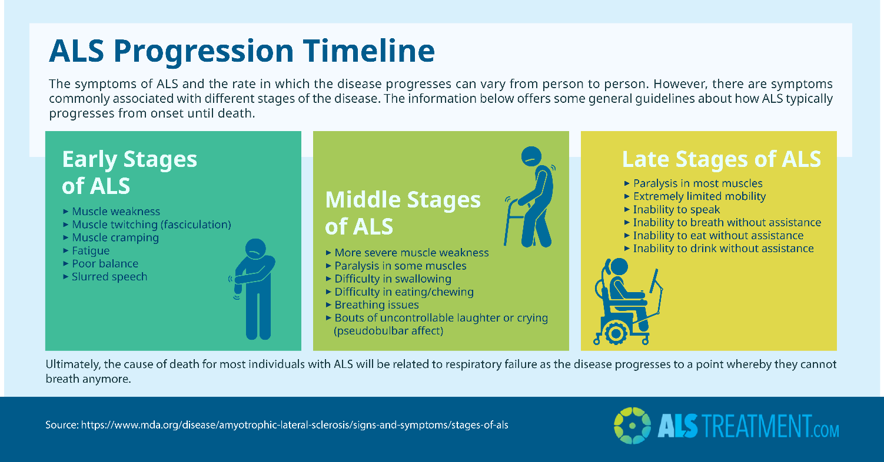
https://alstreatment.com/wp-content/uploads/2018/02/als-progression-timeline-infographic.png Retrieved November 21, 2021.
During the early stages of ALS it becomes immediately important to begin a consistent food regimen of quality and high calorie nutrients. While there is currently much debate, along with ongoing research, into which diet Is considered the best for treating ALS. There is a common belief that a diet rich in essential nutrients, protein to prevent muscle loss and low in processed ingredients will be a significant defense against the devastating neurodegeneration known with ALS. Here in this sample menu you will see the type of diet that is recommended for patients diagnosed with ALS. Primarily the meals are going to be high calorie and paired with easy to swallow ingredients:

https://www.als.org/navigating-als/resources/fyi-high-calorie-and-easy-chew-recipes Retrieved November 21, 2021.

Once the middle stages of ALS begin to occur the need may begin to arise for help with everyday functions such as walking, feeding and other motor functions. The patient’s need for calories will remain high and if the patient is having difficulty intaking enough calories. The patient should consider opting for foods that are both higher in calories and also easier to chew and swallow such as avocado, butter, honey or peanut butter. The patient should be placed on a dietary regimen that includes eating every 3-4 hours so as to make sure that they are consistently consuming enough. Another recommendation to ensure caloric needs are being met is the adding of nutritional supplements to meals such as Boost or Ensure. Because of the weakening in a patients muscles, particularly their abdominal muscles, coupled with a patients limited mobility there is a greater risk for dehydration and constipation. To counter this potentially uncomfortable side effect, medical professionals recommend consuming at least 8 cups of water per day as well as including substantial fiber volume such as prune juice in the patients diet.
The late stages of ALS will require much more third party care due to the patients extremely limited mobility from the advancing disease. By this point most of the skeletal muscle have been affected and the patient will be relying solely on medical assistance for daily living. It is common at this point, although sometimes it is chosen much earlier, to have a feeding tube also known as a PEG inserted. This feeding tube can be an important asset to a patient, especially if they deteriorate to the point of becoming physically incapable of chewing and swallowing. The tube will allow the patient to be able to intake the appropriate nutrients as well as attempt to maintain as healthy a BMI as possible. Even at this advanced stage it is still extremely important to maintain a nutritious dietary routine and to keep the patient from becoming malnourished.
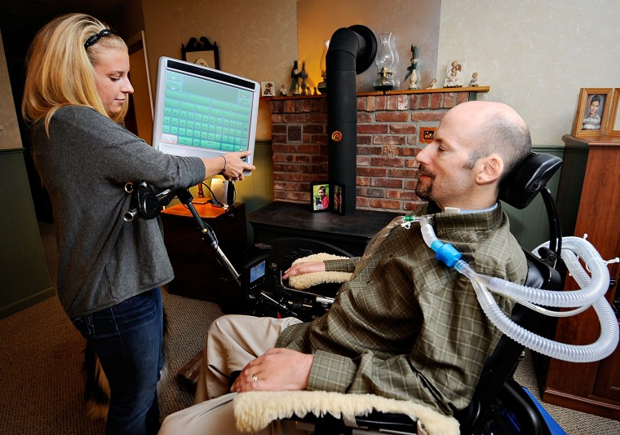
http://glamroz.com/wp-content/uploads/2014/08/veterans-als-disability-linked-to-gulf-war-illness4.jpg Retrieved November 21, 2021.
THERAPY
Therapeutic care is vital for an ALS patient as it has the potential to significantly extend their life expectancy. These are some of the different therapies used in the course of managing the effects of ALS.
- Physical and Occupational Therapy
- Speech Therapy
- Respiratory Therapy
- Psychotherapy
- Medicative therapy
ADDITIONAL RESOURCES
The ALS Association is the primary source for education as well as third party resources for individuals interested in learning more about ALS. They are actively working to raise awareness, support and treatment options for those that have been diagnosed with ALS. The list of links below are all available through the association website and can direct you to support groups that are local to your area.
- https://www.als.org/understanding-als
- https://www.als.org/navigating-als
- https://www.als.org/local-support
- https://www.als.org/research

The ALS Association also offers this nutritional guidebook for patients, friends and family members that are learning to live with ALS:
- ALS Association Nutrition Guidebook.pdf
An additional support resource are the online ALS support groups:
- ALS Community Forum https://www.alsforums.com/
- ALS Therapy Development Institute: ALS Forum https://www.als.net/forum/

